Q.1. Write the answers based on the following table:

Table: Manger

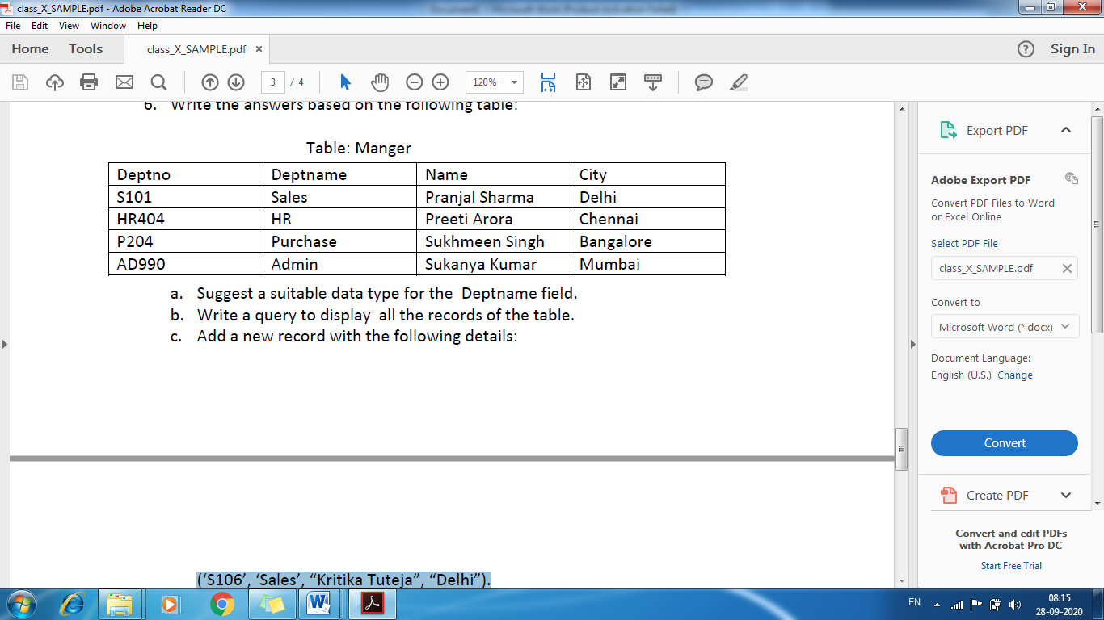

1. a. Suggest a suitable data type for the Deptname field.
2. b. Write a query to display all the records of the table.
3. c. Add a new record with the following details:

(‘S106’, ‘Sales’, “KritikaTuteja”, “Delhi”).

1. Ans a) Varchar

b) Select * from Manger;

c) Insert into Manger(‘S106’,’Sales’,’Kritika Tuteja’,’Delhi’);

Q.2

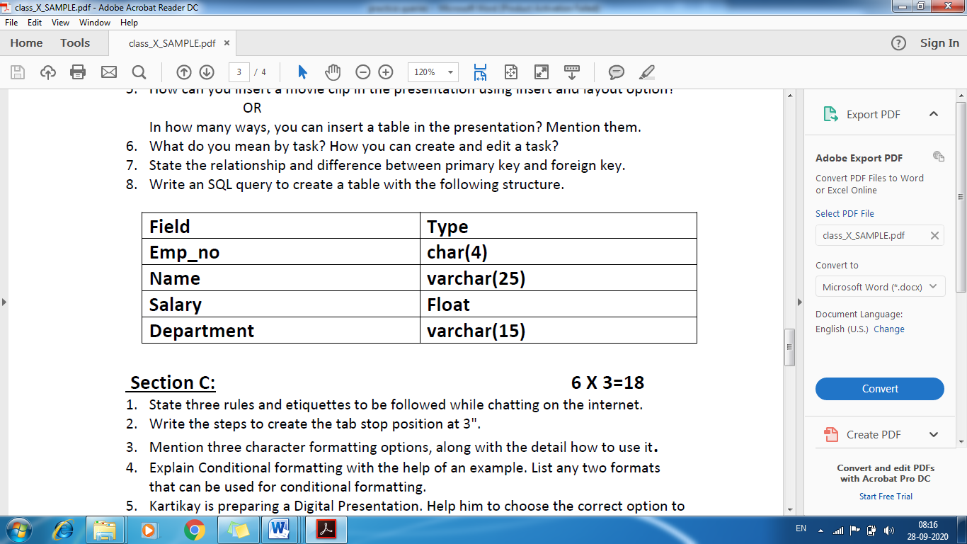

2. Ans: Create table employee(Emp_no char(4), Name varchar(25), Salary float, department varchar(15));

Q.3

***FOR WRITING SQL QUERIES :***

•SQL statements are not case sensitive.

•Place a semicolon (;) at the end of the last clause.

•SQL statements can be on one or more lines.

•Keywords cannot be abbreviated or split across lines.

•Clauses are usually placed on separate lines.

•Tabs and indents are used to enhance readability.

The general form is :

SELECT COLUMN NAME….

FROM TABLE NAME

WHERE CONDITION;

EXAMPLE : TABLE NAME IS STUDENT

|  |  |  |  |
| --- | --- | --- | --- |
| ROLLNO | NAME | ENG | MATHS |
| 1 | RAJ | 54 | 66 |
| 2 | RAM | 44 | 77 |
| 3 | ROSHNI | 77 | 79 |
| 4 | ROHAN | 23 | 98 |

Write MYSQL Queries for the following :

1. To create the given table.
2. To display all the data from table.
3. To display only name and ENG from table.
4. To display ENG and MATHS from the table whose Rollno is greater than 2.
5. To insert one more row as (5,”resham”,55,76)
6. To delete the record of those students who are having ENG less than30.
7. To update the ENG as 49 of those students Where rollno is less than 3

Answers :

1. CREATE TABLE STUDENT (ROLLNO INTEGER(20),NAME CHAR(25),ENG INTEGER(4), MATHS INTEGER(4));
2. SELECT * FROM STUDENT;
3. SELECT NAME,ENG FROM STUDENT;
4. SELECT ENG,MATHS FROM STUDENT WHERE ROLLNO >2;
5. INSERT INTO STUDENT VALUES(5,”RESHAM”,55,76);
6. DELETE FROM STUDENT WHERE ENG<30;
7. UPDATE STUDENT

SET ENG=49

WHERE Rollno<3;

Q.1 write the commands based on this table

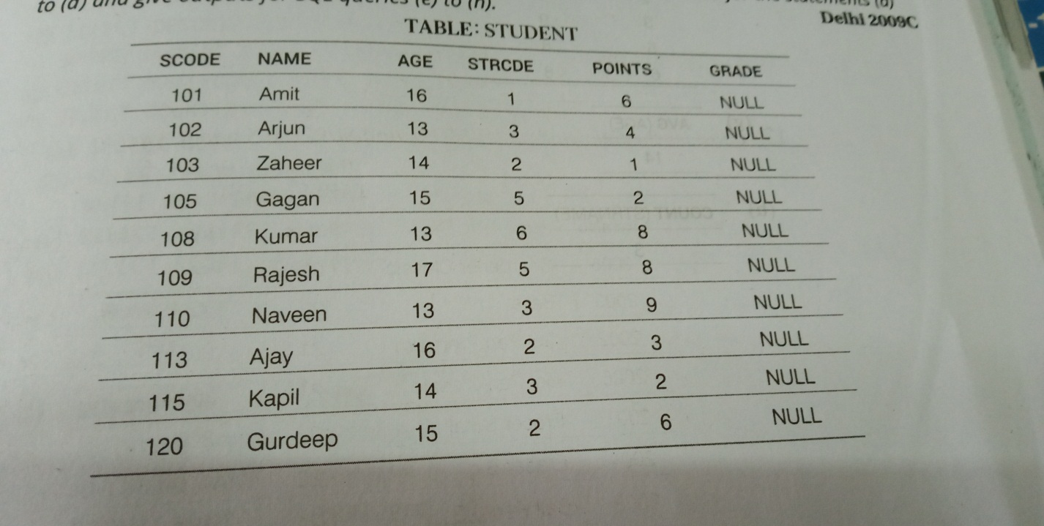

**A)Create the following table.**

Ans: Create table student(Scodeinteger,Namevarchar(25), Age integer, strcde integer, points integer);

**B)To display the details of those students whose age is greater than 15**

Ans : Select * from student where age>15

**c) To display the details of all students in descending order of Points**

Ans: select * from student order by Points desc;

**d) To display the details of Arjun**

ans: Select * from student where name=’Arjun’;

Q.

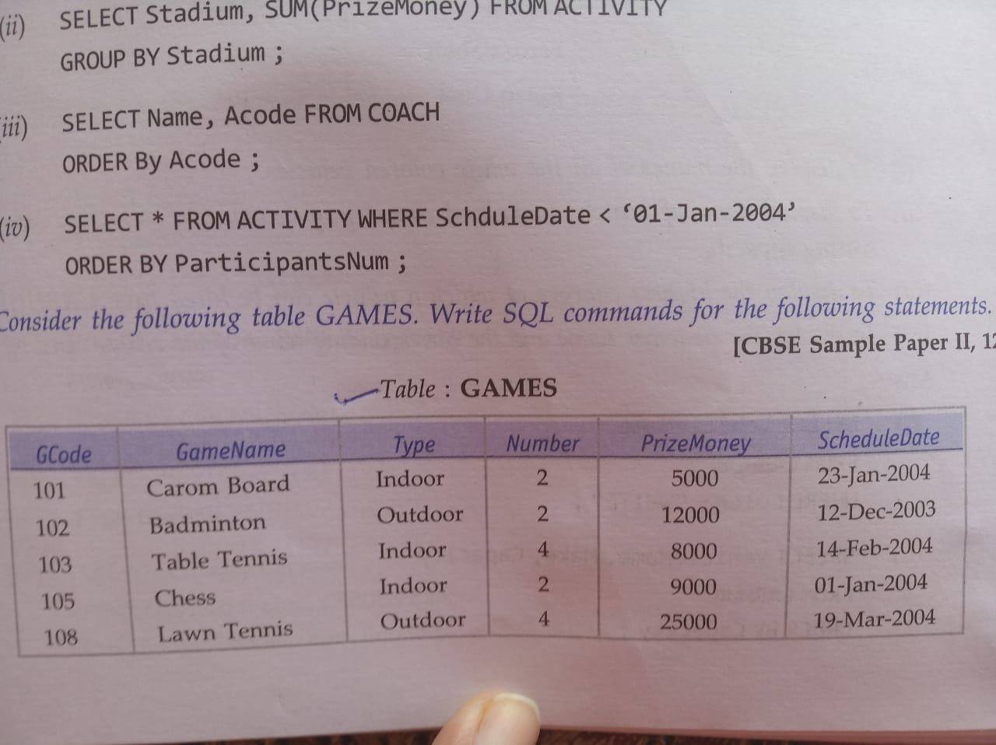

1. **To display the names of all games with their GCodes**.

Ans: Select Gamename,Gcode from games;

1. **To display details of those games which are having Prizemoney more than 7000**.

Ans: Select * from games where prizemoney> 7000;

1. **To display the content of the games table in ascending order of schedule date**

Ans : Select * from games order by Scheduledate;

1. **To display the indoor games.**

Ans: Select * from games where type=”indoor”

1. **To display the details of games started after 1st jan,2004**

Ans : Select * from games where ScheduleDate>01-jan-2004;

Q

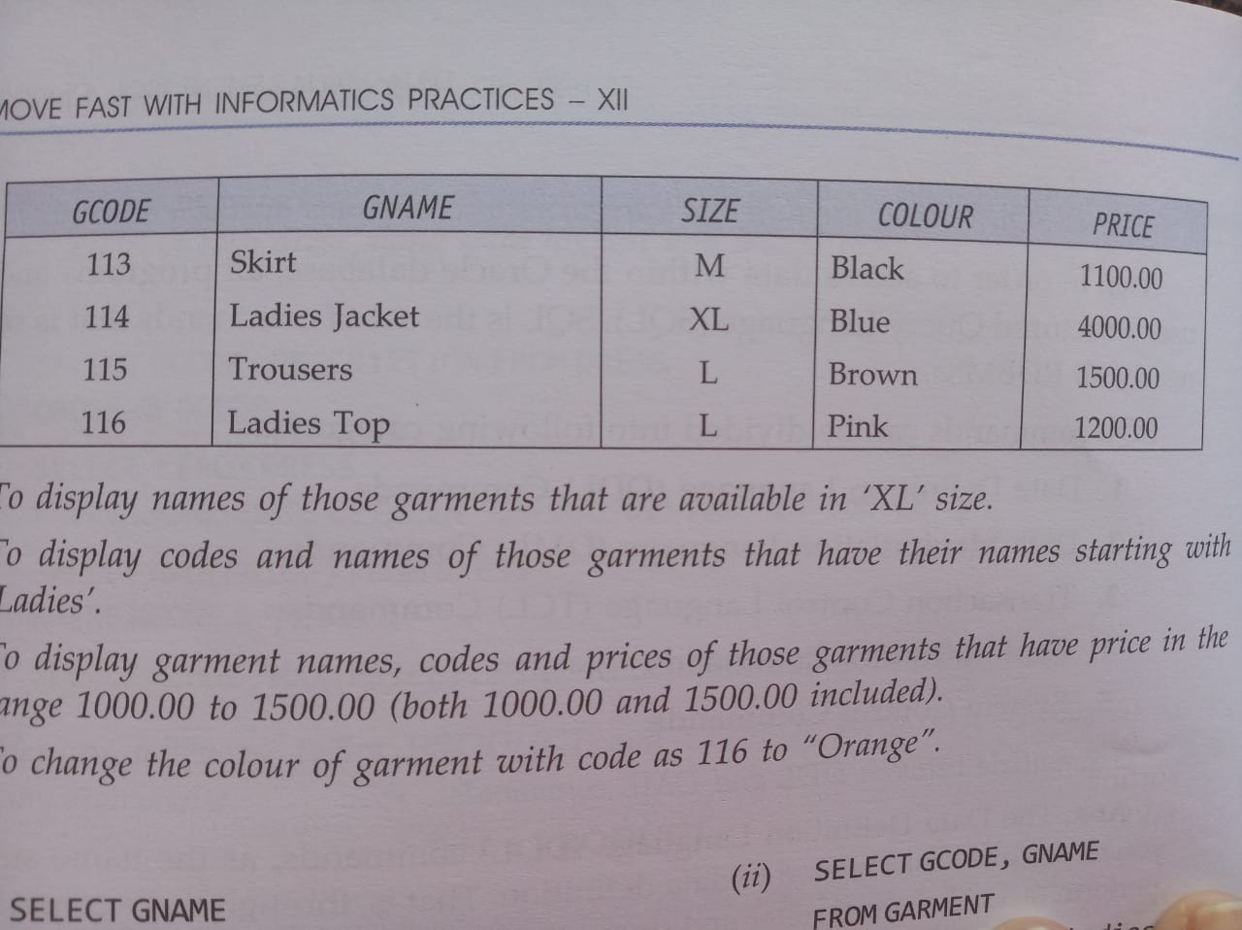

Ans : select Gname from garment where size=’XL’;

**Q. To change the colour of garment with code as 116 to ‘Orange’**

Ans: Update Garment set Colour=’Orange’whereGcode=116;

Queries

TO